
Academia Internacional David
Robotics and Technology
Arduino/Freenove Safety and Components Check

Name: _____________________________ | Date: __________________
Group: 8° A B
Instructions: Label the Arduino parts, then apply safe physical-computing habits.

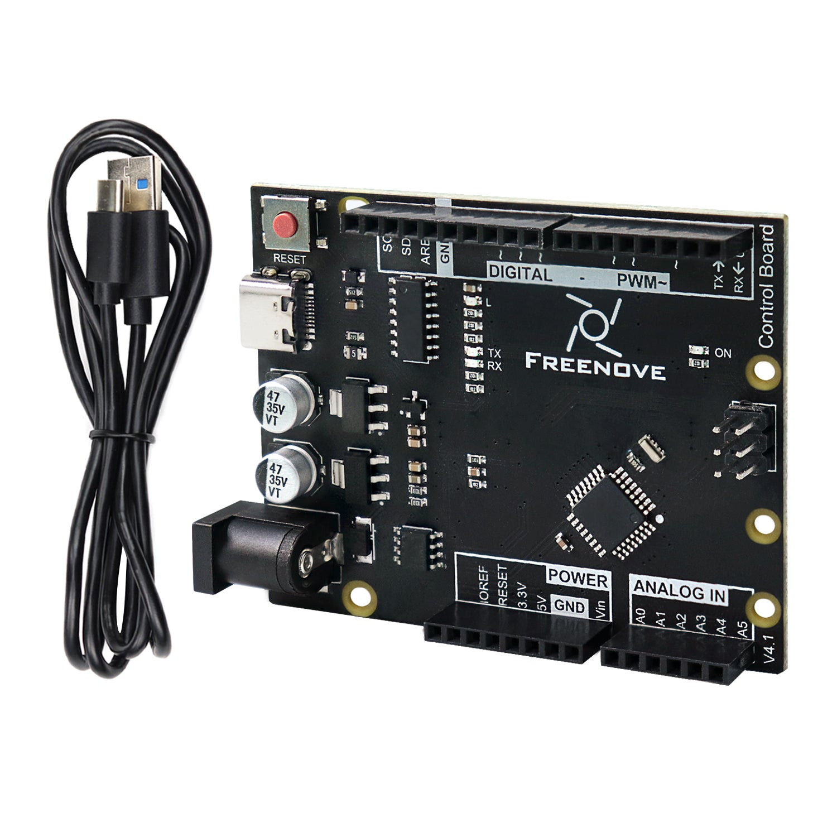
Part A - Component Labels (16 pts
# | Required Component | Label / Purpose
1 | USB cable
2 | USB port
3 | digital pins
4 | analog pins
5 | 5V
6 | GND

Part B - Circuit Reasoning (12 pts)
9. Why is GND needed in a circuit? (3 pts)
____________________________________________________________________________
10. When might you use a digital pin instead of an analog pin? (3 pts)
____________________________________________________________________________
11. How do breadboard rows help you connect components? (3 pts)
____________________________________________________________________________
12. Why should power rails be checked before adding components? (3 pts)
____________________________________________________________________________

Part C - Safety Rule and Risk (12 pts)
13. Write one safety rule for Arduino/Freenove work and explain what problem it prevents. (6 pts)
____________________________________________________________________________
____________________________________________________________________________
14. A circuit does not work after upload. Name two things you should check before asking the teacher to fix it. (6 pts)
____________________________________________________________________________
____________________________________________________________________________

